An alcohol, which contains one $–OH$ group is called __________.
A. Monohydric
B. Dihydric
C. Trihydric
D. None of these
ANSWER: A
General name of Trihydric alcohols is:
A. Glycine
B. Glycol
C. Glycerol
D. Ethylene
ANSWER: C
An alcohol, which contains more than three $–OH$ group are called __________ alcohols.
A. Monohydric
B. Dihydric
C. Trihydric
D. Poly hydric
ANSWER: D
If $OH-$group is linked to a primary carbon atom such as alcohol is classified as:
A. Primary-alcohol-$1^{0}$
B. Secondary-alcohol-$2^{0}$
C. Tertiary-alcohol-$3^{0}$
D. None of these
ANSWER: A
$R_{3}COH$ is an example of:
A. Primary alcohol
B. Secondary alcohol
C. Tertiary alcohol
D. None of these
ANSWER: C
General formula of monohydric alcohol is:
A. $C_{n}H_{2n-1}OH$
B. $C_{n}H_{2n+1}2OH$
C. $C_{n}H_{2n+1}OH$
D. $C_{n}H_{2n}OH$
ANSWER: C
Alcohols (monohydric) and ethers are _____________ isomers of each other.
A. Skeletal
B. Position
C. Functional group
D. Metamers
ANSWER: C

Common name of $C_{3}H_{7}OH$ is:
A. Methyl alcohol
B. Propyl alcohol
C. Ethyl alcohol
D. Benzyl alcohol
ANSWER: B
Name the following compound:
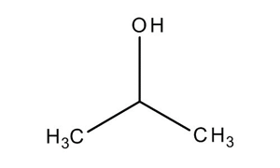
A. Secondary propyl alcohol
B. Primary propyl alcohol
C. Tertiary propyl alcohol
D. Poly propyl alcohol
ANSWER: A
The IUPAC name of following compound is:
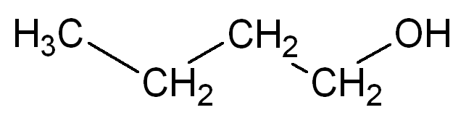
A. Butyl alcohol
B. n-butanol
C. 1-butanol
D. Primary butyl alcohol
ANSWER: C

IUPAC name of the following compound is:
$$OH-CH_{2}-CH_{2}-CH_{2}-CH_{2}-OH$$
A. 1,4-diol-butane
B. Butane-1,4-diol
C. Secondary butyl alcohol
D. 1,4-di butyl alcohol
ANSWER: B
IUPAC name of the following compound is:
$$OH$$
$$CH_{3}-CH-CH_{2}-CH_{2}-OH$$

A. Butyl-diol
B. Butane-2,4-diol
C. Butane-1,3-diol
D. Butanol-diol
ANSWER: C
IUPAC name of the following compound is:
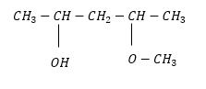
A. 4-methoxy-2-hydroxyl pentane
B. 2-hydroxy-4-methoxy pentane
C. 2-methoxy-4-pentanol
D. 4-methoxy-2-pentanol
ANSWER: D

IUPAC name of the following compound is:
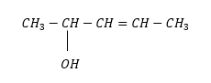
A. 3-penten-2-ol
B. 2-penten-4-ol
C. Pentan-2-ene-3-ol
D. All of these
ANSWER: B
IUPAC name of the following compound is:

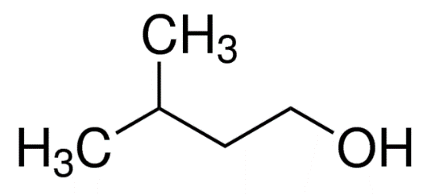
A. n-pentanol
B. 3-methyl-1-butanol
C. 2-methyl-4-butanol
D. Primary pentyl alcohol
ANSWER: B

